1. The distance/displacement-time graphs below represent the motion of a car. Match the descriptions with the correct graph.
Descriptions:

- The car is stopped.
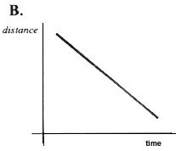
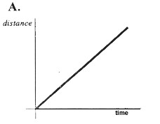
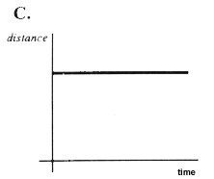
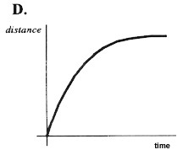
- The car is traveling at a constant speed.
Distance
Distance
Distance
Displacement
- The speed of the car is decreasing.
- The car is coming back.
- Graph A matches description _____ because ______________________________.
- Graph B matches description _____ because ______________________________.
- Graph C matches description _____ because ______________________________.
- Graph D matches description _____ because ______________________________.

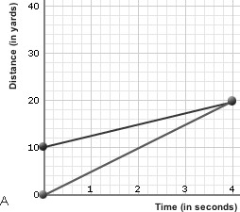
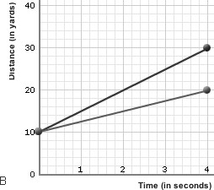
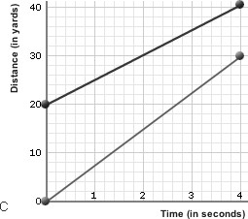
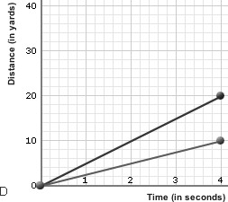
2. Students were set up in pairs to run races. Four races were run. Because the students were at different ability levels, some had a head start, but all races were 4 seconds long. The four race results are shown below as distance versus time graphs – A to D.
A. B. C. D.
Runner 1
Runner 2
Runner 7
Runner 8
Runner 6
Runner 5
Runner 4
Runner 3
(i) Which graph shows one student with a 10 metre head start. ________________________
(ii) In which race did the students finish side by side (together) ________________________
(iii) In race A, which runner was the fastest runner? Explain your answer ________________ _____________________________________________________________________________
(iv) Which of the eight runners was the fastest? Explain your answer ___________________ _____________________________________________________________________________
(v) Who were the slowest runners? _______________________________
(vi) Calculate the speed of runner 7.

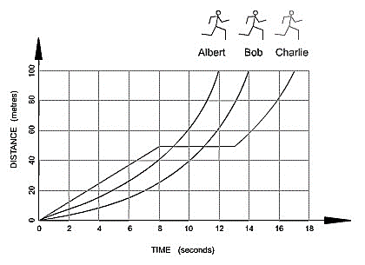
3. Three boys ran a 100metre race and the results were shown on a distance versus time graph shown on the right.
Use this data to answer the following questions:
- Which runner won the race and what was his time?

- Which runner ran some of the race at a constant speed? Explain your answer.

- How long did one of the runners rest for?
- Calculate the speed of Albert and Charlie.

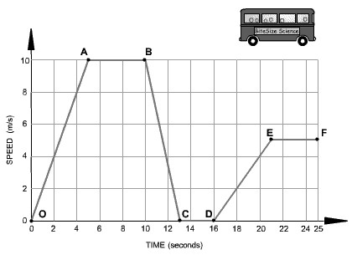
Velocity (m/s)
4. The motion graph on the right shows a school bus trip that happened to be very short (25 seconds long).
(a) For each sentence below, choose the best phrase/word or number to fill the blanks. You may choose from some of these phrases/words provided below
- accelerating | - constant velocity
- decelerating | - at rest

Segment 0-A: The bus is __________________. Its velocity changes from 0 to ______ m/s in 5 s.
Segment A-B: The bus is moving at a _____________________ of 10 m/s for ______seconds.
Segment B-C The bus is __________________. Its velocity changes from 10 m/s to ___ in 3 s.
Segment C-D The bus is __________________. It has stopped.
Segment D-E The bus is ____________________. It is gradually increasing in velocity.
(b)*^{Hard Q} Calculate the distance travelled by the bus in segment 0- A.

